**Benjamin Tisinger**

IST 615 – Lab #4 Azure Part 2

2/24/2024

**What is Microsoft Azure:**

**Getting Started with Azure Accounts:**

**Exercise – Explore the Learn Sandbox:**

**Describe Azure Physical Infrastructure:**

**Describe Azure Management Infrastructure:**

**Create an Azure Resource:**

**Describe Azure Virtual Machine:**

**Describe Application Hosting:**

**Configure Network Access:**

**Achievement:**

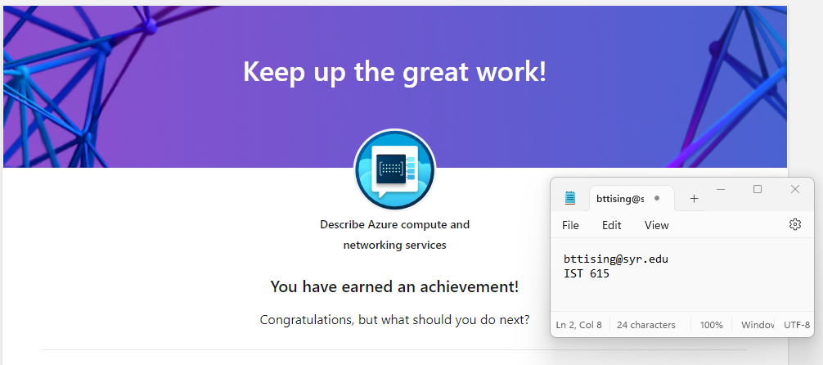

**Describe Azure Storage Services:**

**Describe the Core Architecture Components of Azure:**



